The automobile is perhaps the most important invention second only to electricity in the 20th century. It has changed life of man in a way unimaginable before its invention. "The world travels on wheels" is the buzzword of the 20th century. The manufacturing of these automobiles is both a fascinating and challenging task. The simulation team has simulated the manufacturing process of wagons, sedans and convertibles in a Toyota car plant.

The following is the step by step procedure for the manufacturing of cars in the "Toyota Production System":

1. The manufacturing process begins with the chassis assembly. The chassis is the skeleton of the car. It is the part on which the car is built.
2. Axle and tires are fitted to the chassis assembly.
3. In the next stage, the engine is fitted to the chassis. The engine is the power-producing component of the car. The power produced in the engine is use to propel the car. Engines are mostly of the internal combustion type.
4. The gearbox is then fitted into the chassis. The gearbox is the component that is used to change the speed supplied to the wheels.
5. The next stage involves the fitting of the radiator into the engine. The radiator helps in cooling the engine, transmitting the excess heat to the surrounding by conduction.
6. The seats are then fitted to the car in the next stage.
7. The battery is then fitted and electrical connections are carried out. The electrical connections connect the various components of the car to the battery.
8. The body of the car is then fitted on the chassis.
9. The windshield, doors, and wipers are fitted to the car along with the bonnet.
10. The finishing touches are carried out on the car.
11. The car is then sent for inspection and testing after which it is taken to the parking lot and kept ready for shipping.

Below is a block diagram describing the manufacturing flow.

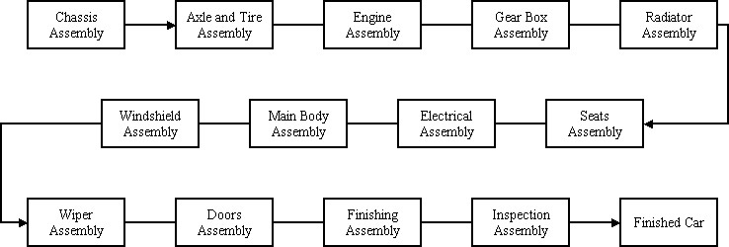

**Attributes**

1. Worktime: If the job arriving at the workstation is a Hardtop or a Wagon it is delayed by the duration given in the work time attribute of the delay block.
2. Optime (operation time): If the job arriving at the workstation is a Sedan it is delayed by the duration given in the Op time attribute of the delay block.
3. Setindex: Corresponds to a specific workstation in the set of stations.
4. Timein (time in): Denotes the time at which a job arrived in the system.
5. Jobtype (type of job): Denotes that the type of job is a hardtop, wagon or sedan.

**Sets**

1. Queueset: Signifies all the queues along the main assembly line, which are sequentially visited by the job.
2. Stationset: Corresponds to all the stations along the main assembly line, which are sequentially attended by the job.
3. Resourceset: Denotes all the resources along the main assembly line, which are sequentially attended by the job.

**Counters**

1. Wagons: Number of wagons produced
2. Hardtops: Number of hardtops produced
3. Sedans: Number of Sedans produced
4. Total cars: Total number of cars produced

**Variables**  
Every job is delayed at the workstation for a specific duration. This is obtained by fitting the historical data in the input analyzer. In the manufacturing model case the duration of the delay is LOGNORMAL with a mean and standard deviation. Since there are three different types of jobs with different delays, a variable array is defined with constants for the distribution. Each constant in the array signifies a part of the operand for a specific job in the delay block. The following three constants have been defined:

1. Mean
2. C
3. Std